**Experiment No.: 6**

**Setup a network and configure IP addressing, subnetting, Masking using Cisco Packet Tracer**



1. **Aim: S**etup a network and configure IP addressing, Subnetting, Masking using Cisco Packet

Tracer

1. **Objectives:** To introduce concepts of configurations IP addressing, Subnetting and Masking.
2. **Outcomes:** The learner will be able to

* Analyze the functioning of various networking devices.
* Use the simulation tool Cisco Packet Tracer for building networks.
* Recognize the need for IP addressing, Subnetting and Masking

1. **Hardware/Software required:** Cisco Packet Tracer
2. **Theory**

**Setting a subnetwork**

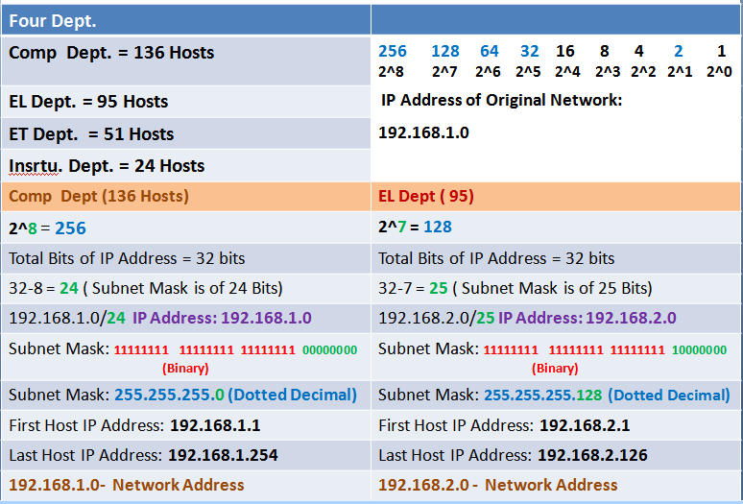

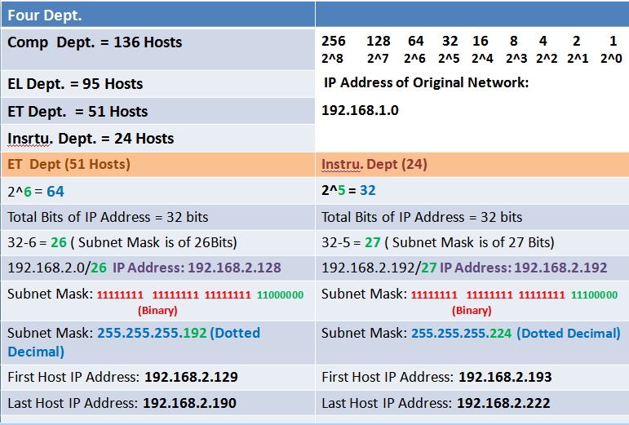

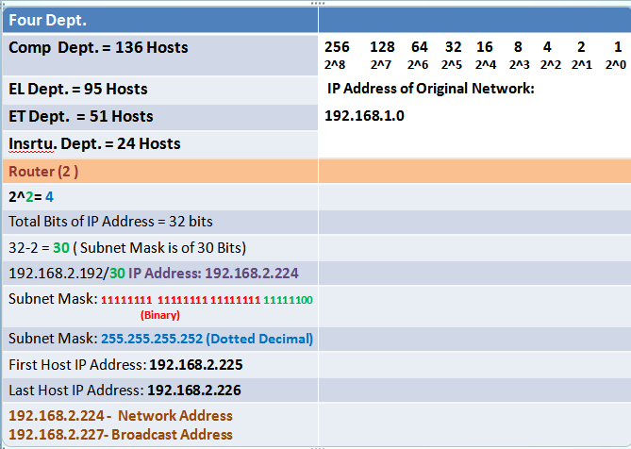

1. Drag and drop the router/switch/computer from the bottom of the screen.

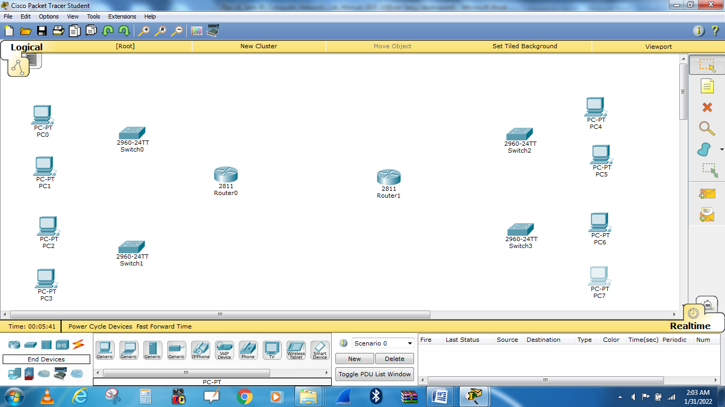

1. Select **end devices** from the bottom left-hand corner and drag it to the sandbox screen.
2. Select **connections** from the same bottom left-hand corner. When you connect like-devices (Such as a router and computer)  you use a crossover cable, so you should select Copper straight-Through, Click on PC0 to Switch0 and *Router0*.

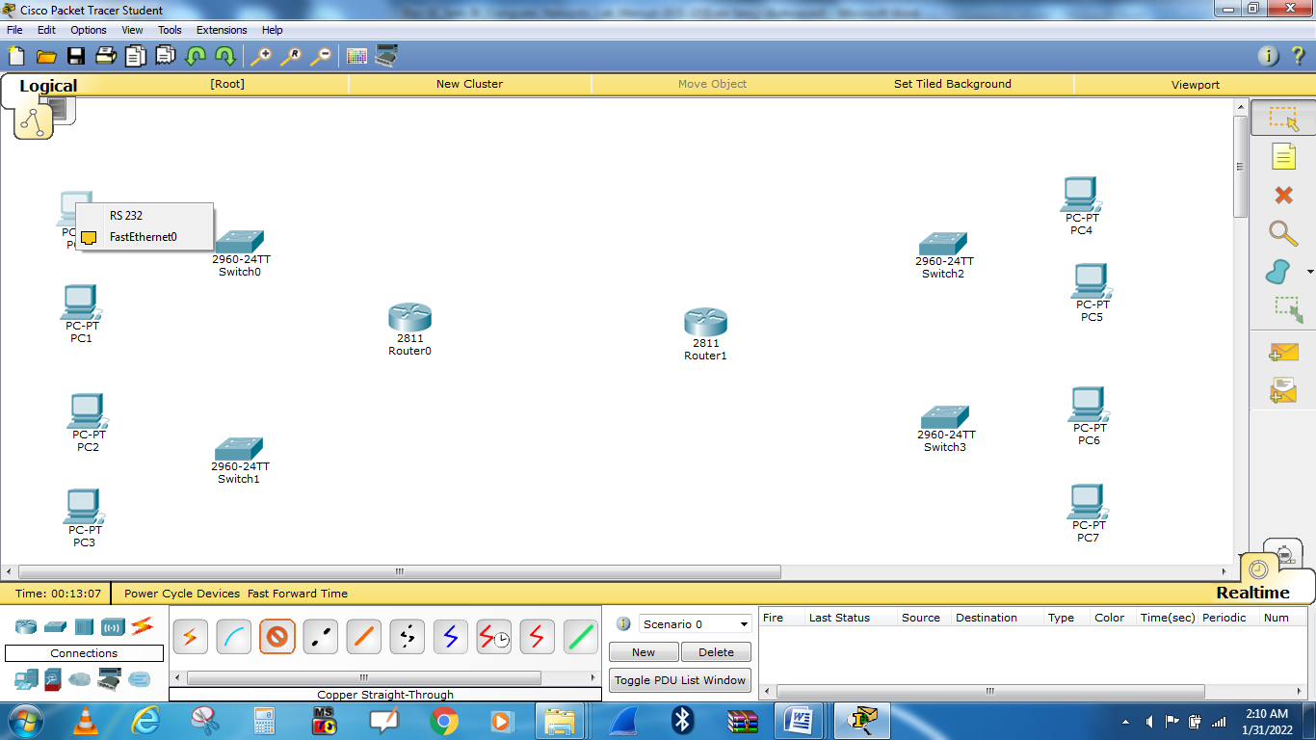

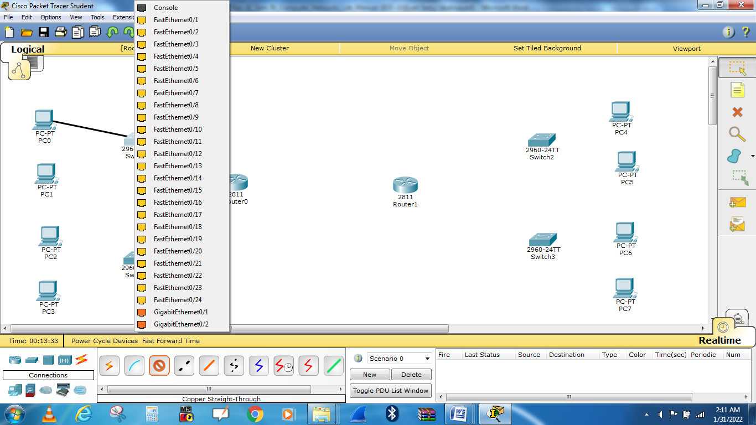

1. Repeat step number 2to connect **PC1,PC2,PC3, and Switch1 to Router0.**

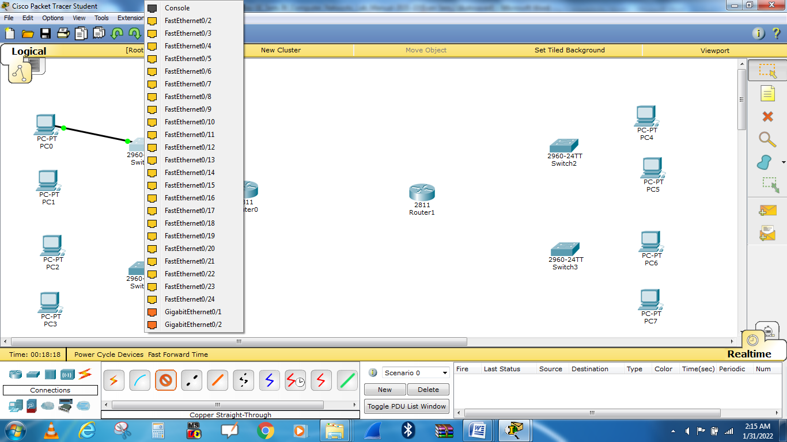

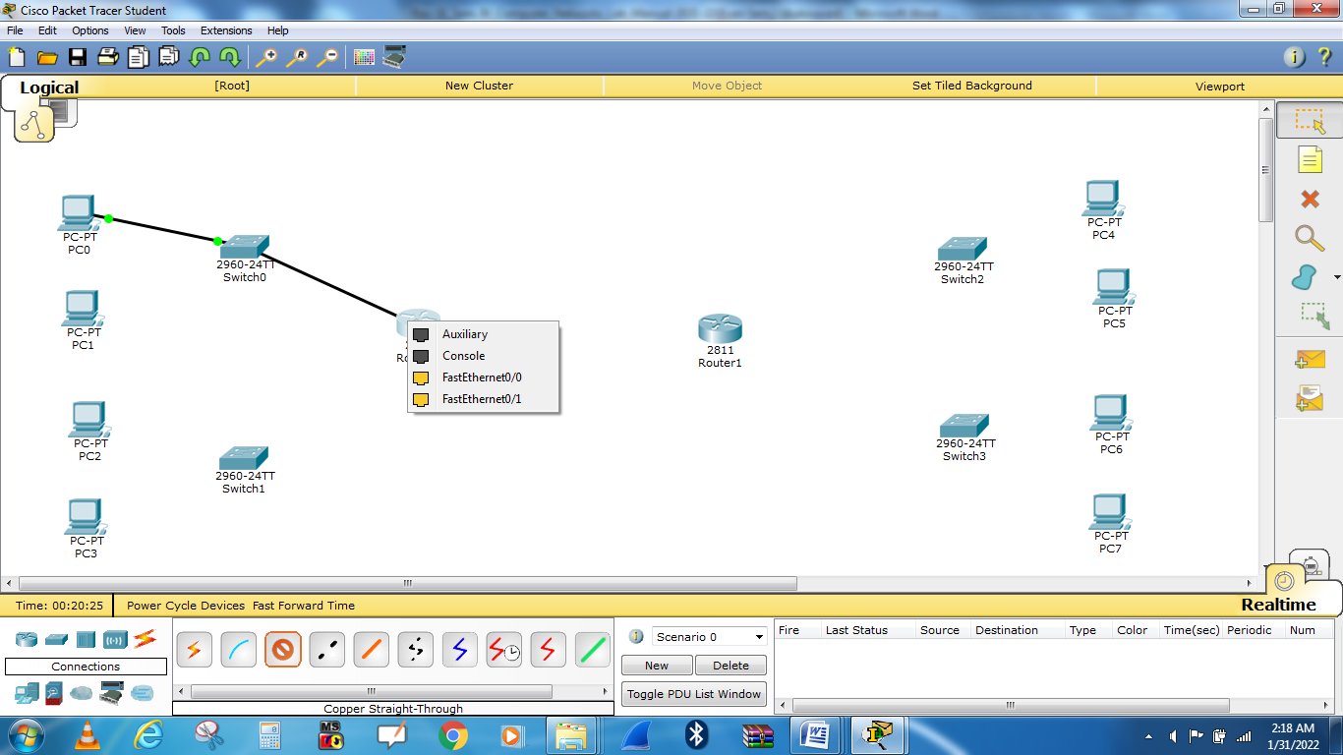

To connect router0 and router1, serial connection is required, Click on router0, First turn off router shown by arrow.

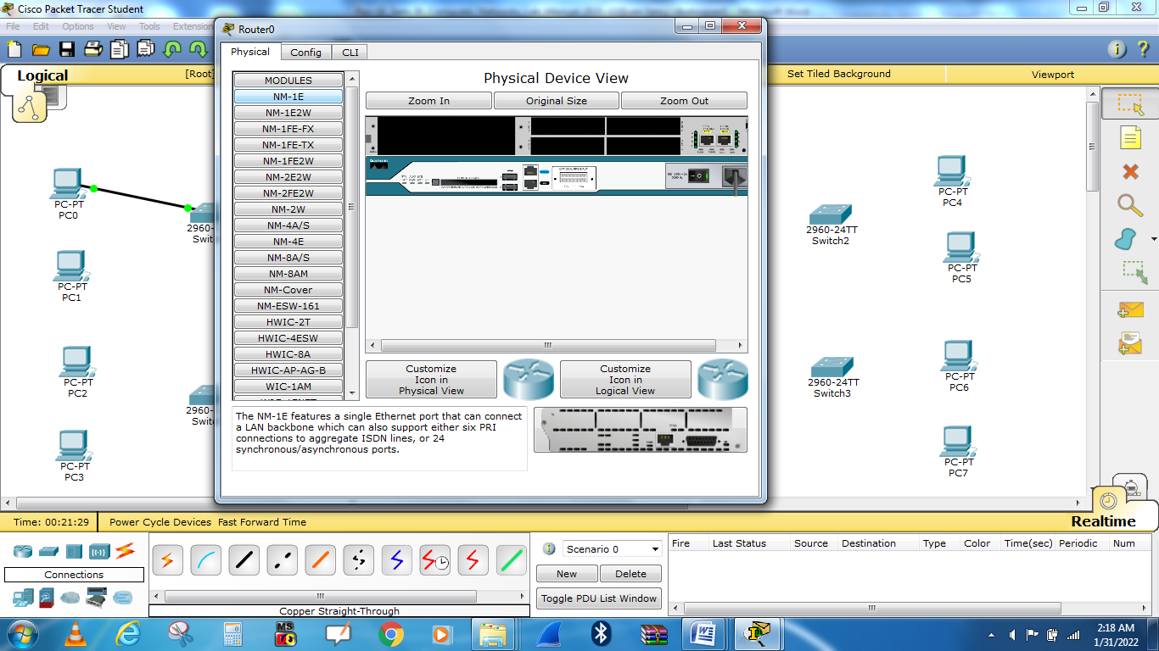

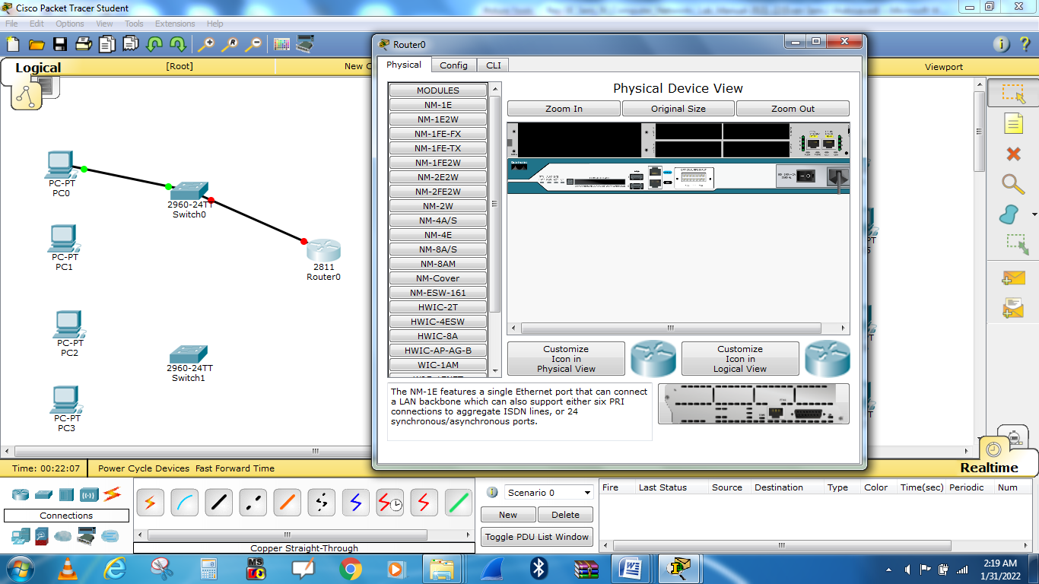

Select WIC 1T interface and Place it to slot shown by arrow.

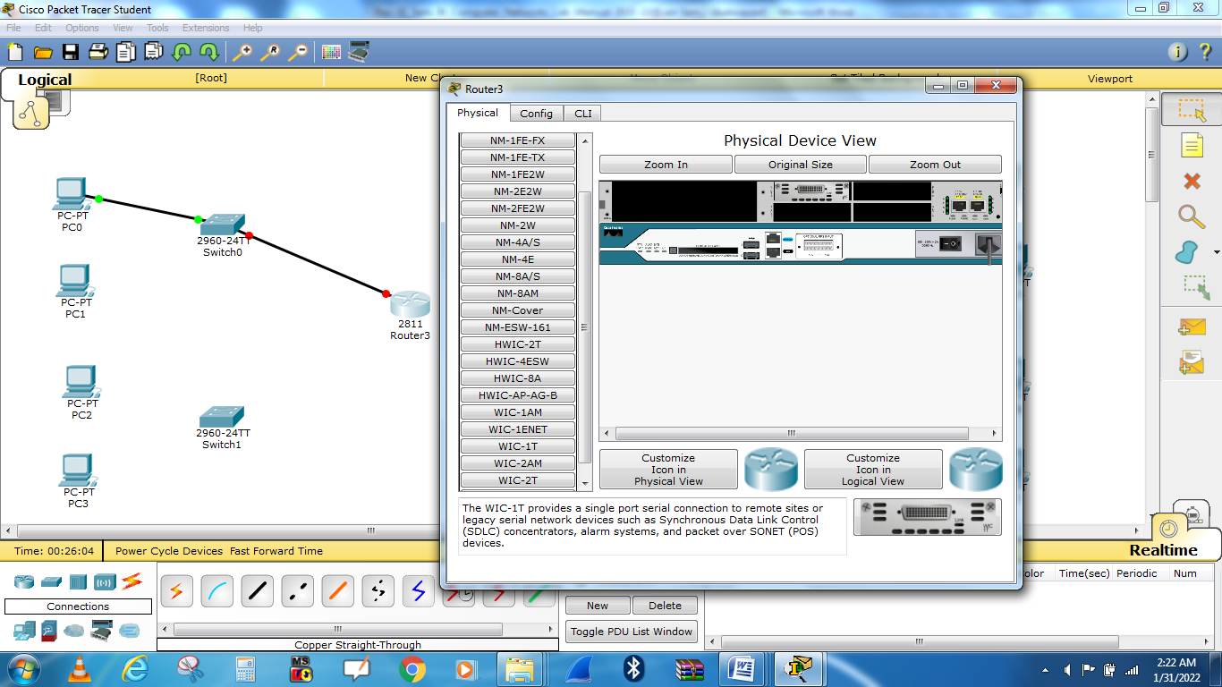

**Repeat same procedure for router1**

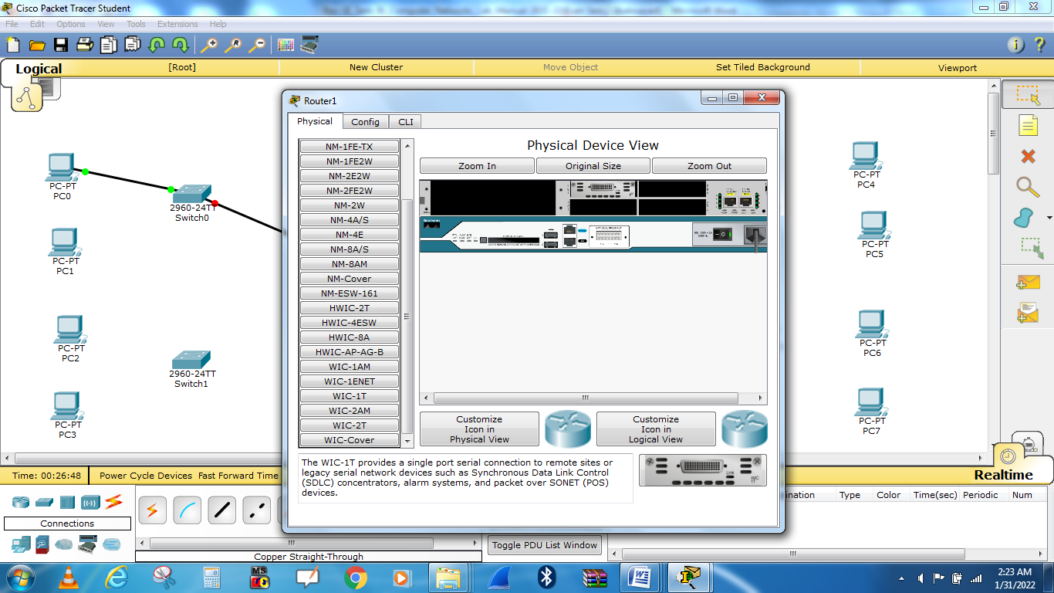

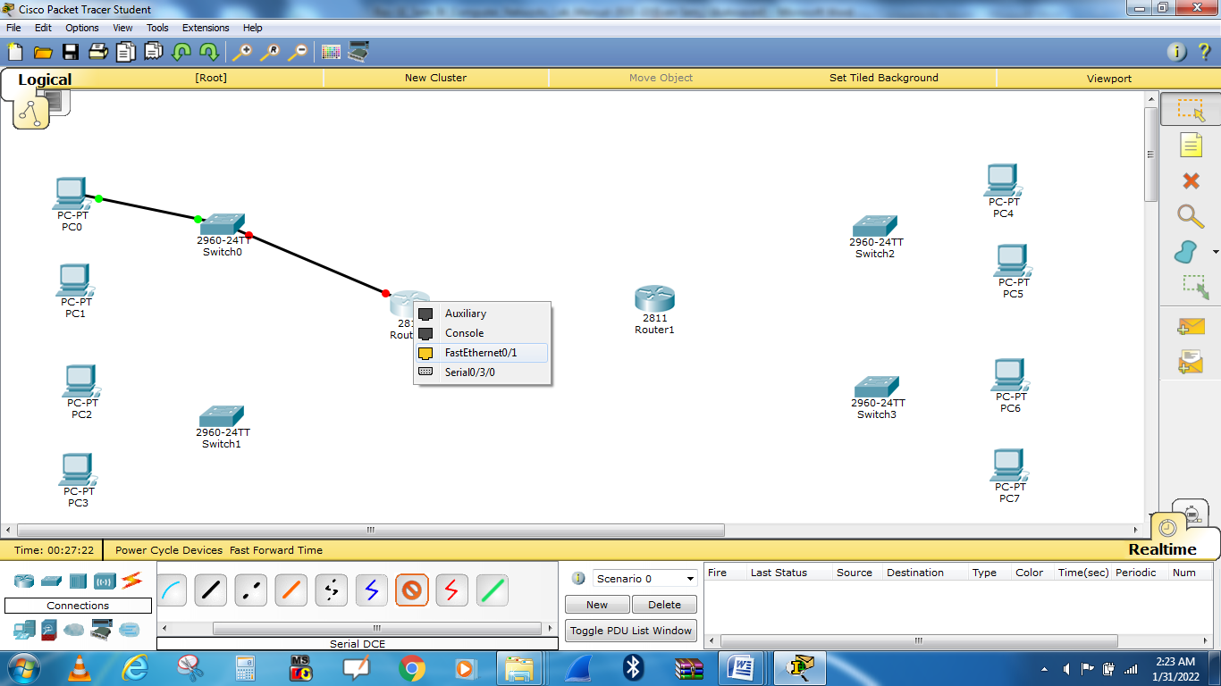

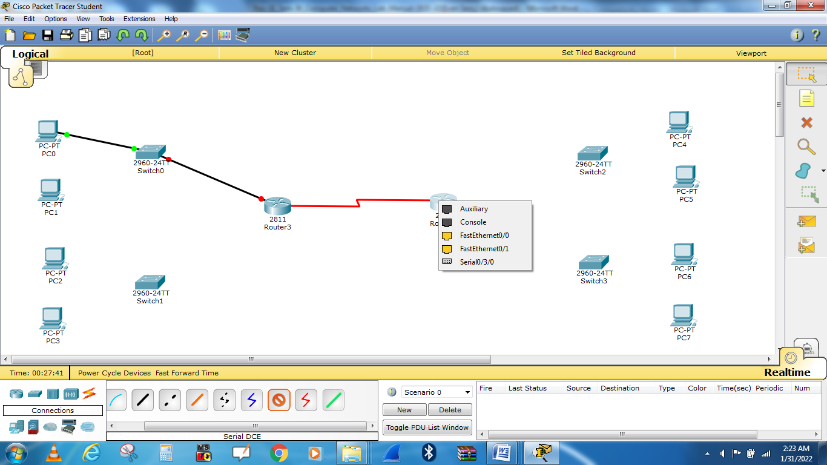

**Configuring the router in packet tracer**

1. Next we have to open the Ethernet ports to allow communication. Although they are physically connected, they are in a state that is known as being in **administrative shut down**. Now click on the **CLI** tab to access the configuration menu.

**Router0**

--- System Configuration Dialog ---

Continue with configuration dialog? [yes/no]: n

Press RETURN to get started!

Router>enable

Router#configure terminal

Enter configuration commands, one per line. End with CNTL/Z.

Router(config)#interface FastEthernet0/0

Router(config-if)#no shutdown

Router(config-if)#

%LINK-5-CHANGED: Interface FastEthernet0/0, changed state to up

%LINEPROTO-5-UPDOWN: Line protocol on Interface FastEthernet0/0, changed state to up

ip address 192.168.1.1 255.255.255.0

Router(config-if)#

Router(config-if)#exit

Router(config)#interface FastEthernet0/1

Router(config-if)#no shutdown

Router(config-if)#

%LINK-5-CHANGED: Interface FastEthernet0/1, changed state to up

%LINEPROTO-5-UPDOWN: Line protocol on Interface FastEthernet0/1, changed state to up

ip address 192.168.2.1 255.255.255.0

Router(config-if)#ip address 192.168.2.1 255.255.255.128

Router(config-if)#

Router(config-if)#exit

Router(config)#interface Serial0/3/0

Router(config-if)#no shutdown

%LINK-5-CHANGED: Interface Serial0/3/0, changed state to down

Router(config-if)#no ip address

Router(config-if)#ip address 192.168.2.225 255.255.255.128

Router(config-if)#no ip address

Router(config-if)#ip address 192.168.2.225 255.255.255.128

Router(config-if)#ip address 192.168.2.225 255.255.255.252

Router(config-if)#

%LINK-5-CHANGED: Interface Serial0/3/0, changed state to up

%LINEPROTO-5-UPDOWN: Line protocol on Interface Serial0/3/0, changed state to up

Router con0 is now available

Press RETURN to get started.

Router>enable

Router#configure terminal

Enter configuration commands, one per line. End with CNTL/Z.

Router(config)#ip route 192.168.2.128 255.255.255.192 192.168.2.226

Router(config)#ip route 192.168.2.192 255.255.255.224 192.168.2.226

Router(config)#

Router(config)#end

Router#copy running-config startup-config

Destination filename [startup-config]?

Building configuration...

[OK]

Router#

%SYS-5-CONFIG_I: Configured from console by console

Router con0 is now available

Press RETURN to get started.

%LINEPROTO-5-UPDOWN: Line protocol on Interface Serial0/3/0, changed state to down

%LINEPROTO-5-UPDOWN: Line protocol on Interface Serial0/3/0, changed state to up

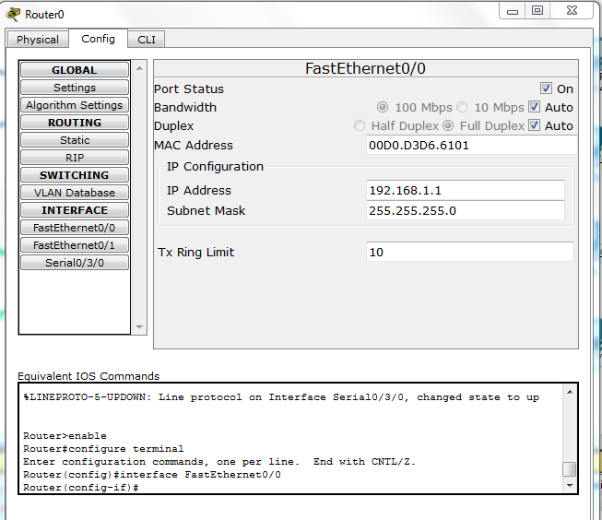

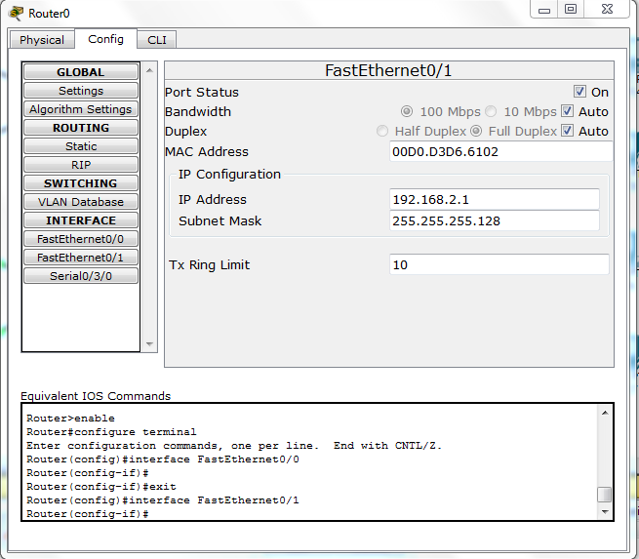

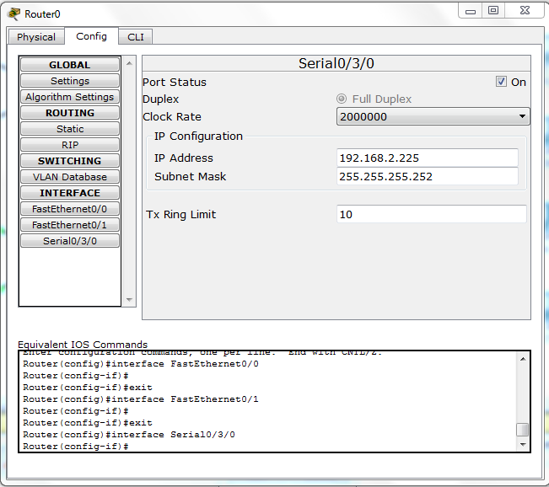

**Router1**

--- System Configuration Dialog ---

Continue with configuration dialog? [yes/no]: n

Press RETURN to get started!

Router>enable

Router#configure terminal

Enter configuration commands, one per line. End with CNTL/Z.

Router(config)#interface FastEthernet0/0

Router(config-if)#no shutdown

Router(config-if)#

%LINK-5-CHANGED: Interface FastEthernet0/0, changed state to up

%LINEPROTO-5-UPDOWN: Line protocol on Interface FastEthernet0/0, changed state to up

no ip address

Router(config-if)#ip address 192.168.2.129 255.255.255.0

Router(config-if)#no ip address

Router(config-if)#ip address 192.168.2.129 255.255.255.0

Router(config-if)#ip address 192.168.2.129 255.255.255.192

Router(config-if)#

Router(config-if)#exit

Router(config)#interface FastEthernet0/1

Router(config-if)#no shutdown

Router(config-if)#shutdown

Router(config-if)#no shutdown

Router(config-if)#shutdown

Router(config-if)#

%LINK-5-CHANGED: Interface FastEthernet0/1, changed state to up

%LINEPROTO-5-UPDOWN: Line protocol on Interface FastEthernet0/1, changed state to up

%LINK-5-CHANGED: Interface FastEthernet0/1, changed state to administratively down

%LINEPROTO-5-UPDOWN: Line protocol on Interface FastEthernet0/1, changed state to down

%LINK-5-CHANGED: Interface FastEthernet0/1, changed state to up

%LINEPROTO-5-UPDOWN: Line protocol on Interface FastEthernet0/1, changed state to up

%LINK-5-CHANGED: Interface FastEthernet0/1, changed state to administratively down

%LINEPROTO-5-UPDOWN: Line protocol on Interface FastEthernet0/1, changed state to down no shutdown

Router(config-if)#

%LINK-5-CHANGED: Interface FastEthernet0/1, changed state to up

%LINEPROTO-5-UPDOWN: Line protocol on Interface FastEthernet0/1, changed state to up

ip address 192.168.2.193 255.255.255.192

Router(config-if)#ip address 192.168.2.193 255.255.255.224

Router(config-if)#

Router(config-if)#exit

Router(config)#interface Serial0/3/0

Router(config-if)#no shutdown

Router(config-if)#

%LINK-5-CHANGED: Interface Serial0/3/0, changed state to up

%LINEPROTO-5-UPDOWN: Line protocol on Interface Serial0/3/0, changed state to up

ip address 192.168.2.226 255.255.255.192

% 192.168.2.192 overlaps with FastEthernet0/1

Router(config-if)#ip address 192.168.2.226 255.255.255.252

Router(config-if)#

Router(config-if)#exit

Router(config)#interface Serial0/3/0

Router(config-if)#

Router con0 is now available

Press RETURN to get started.

Router>enable

Router#configure terminal

Enter configuration commands, one per line. End with CNTL/Z.

Router(config)#ip route 192.168.1.0 255.255.255.0 192.168.2.225

Router(config)#ip route 192.168.2.0 255.255.255.128 192.168.2.225

Router(config)#

Router(config)#end

Router#copy running-config startup-config

Destination filename [startup-config]?

Building configuration...

[OK]

Router#

%SYS-5-CONFIG_I: Configured from console by console

Router con0 is now available

Press RETURN to get started.

%LINEPROTO-5-UPDOWN: Line protocol on Interface Serial0/3/0, changed state to down

%LINEPROTO-5-UPDOWN: Line protocol on Interface Serial0/3/0, changed state to up

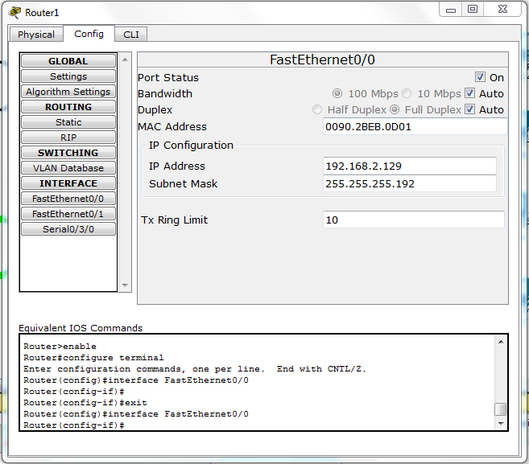

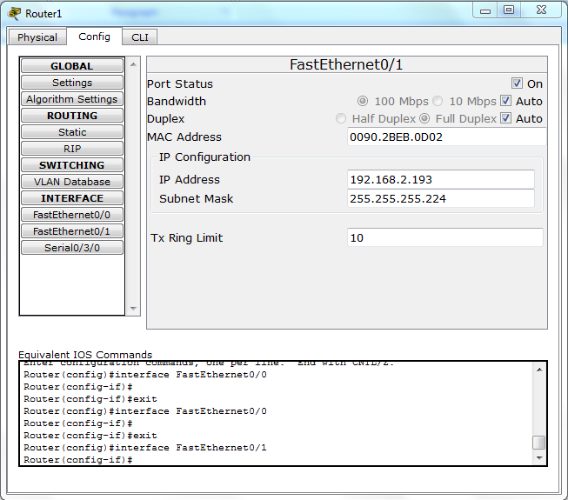

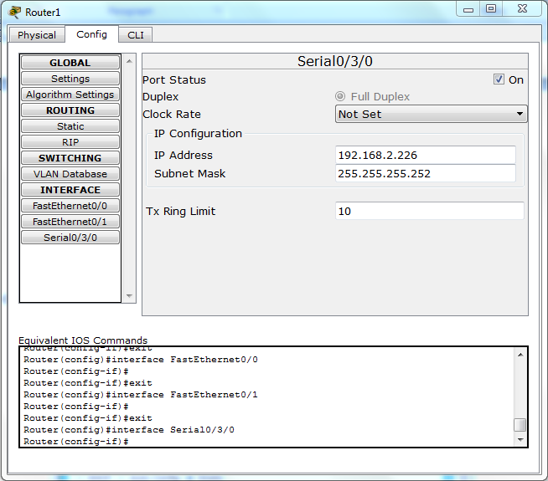

**Static Routing**

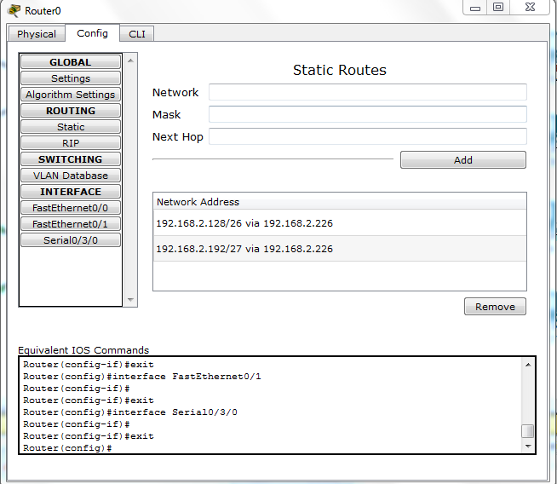

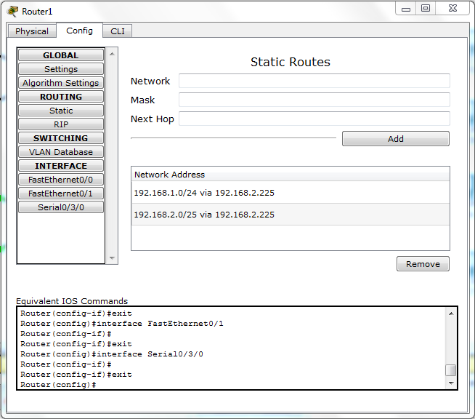

Go to **Config >settings** save configuration of static routing for Router0 and Router1.

**Configuring the PC in packet tracer**

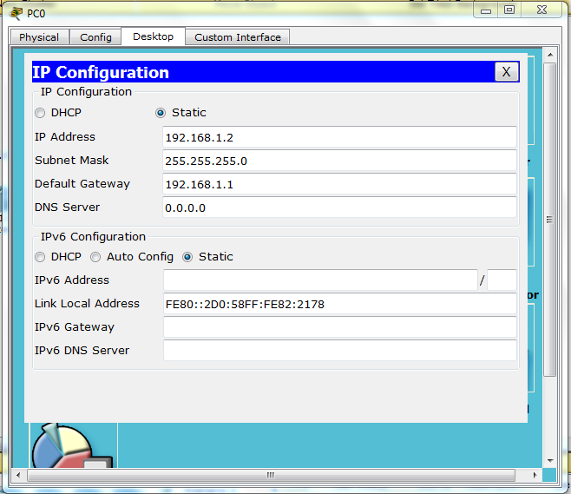

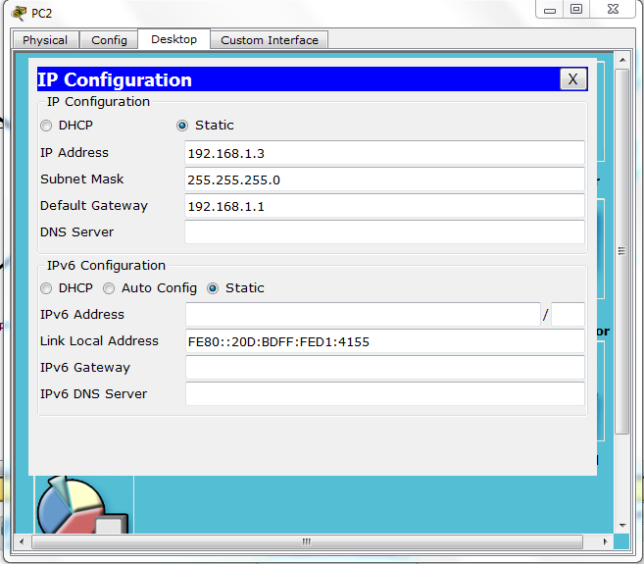

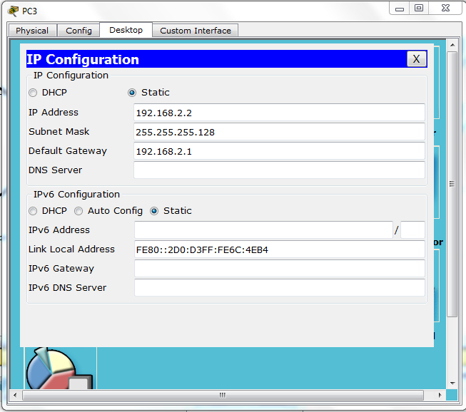

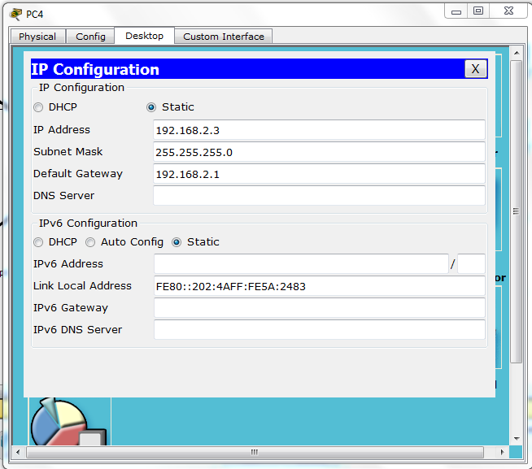

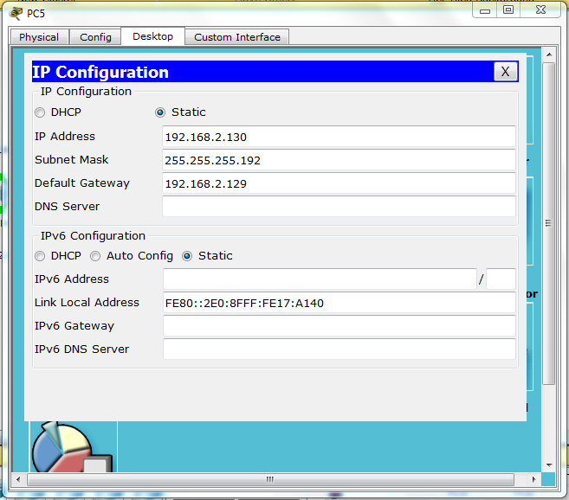

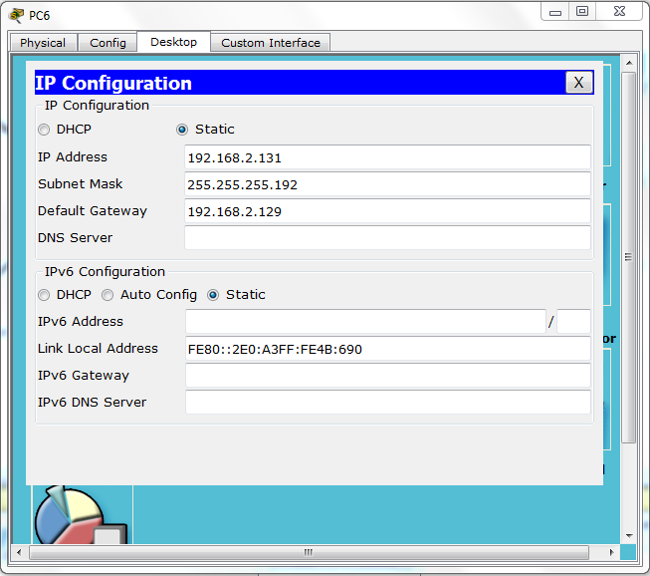

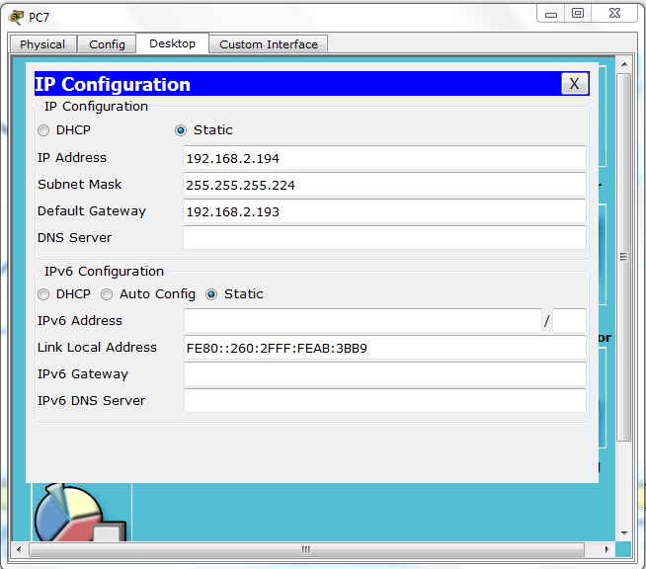

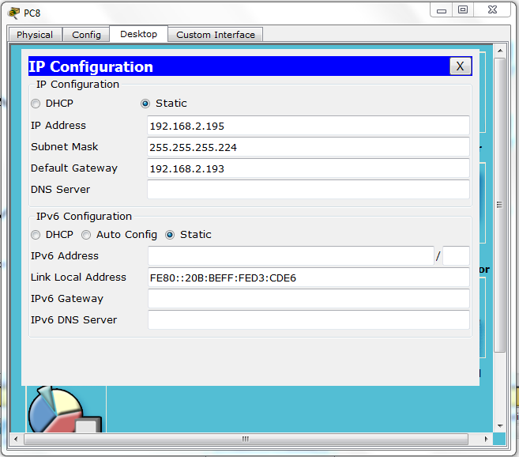

**Router Configuration:**

**Router0**

--- System Configuration Dialog ---

Continue with configuration dialog? [yes/no]: n

Press RETURN to get started!

Router>enable

Router#configure terminal

Enter configuration commands, one per line. End with CNTL/Z.

Router(config)#interface FastEthernet0/0

Router(config-if)#no shutdown

Router(config-if)#

%LINK-5-CHANGED: Interface FastEthernet0/0, changed state to up

%LINEPROTO-5-UPDOWN: Line protocol on Interface FastEthernet0/0, changed state to up

ip address 192.168.1.1 255.255.255.0

Router(config-if)#

Router(config-if)#exit

Router(config)#interface FastEthernet0/0

Router(config-if)#

Router(config-if)#exit

Router(config)#interface FastEthernet0/1

Router(config-if)#no shutdown

Router(config-if)#

%LINK-5-CHANGED: Interface FastEthernet0/1, changed state to up

%LINEPROTO-5-UPDOWN: Line protocol on Interface FastEthernet0/1, changed state to up

ip address 192.168.2.1 255.255.255.0

Router(config-if)#no ip address

Router(config-if)#ip address 192.168.2.1 255.255.255.0

Router(config-if)#ip address 192.168.2.1 255.255.255.128

Router(config-if)#

Router(config-if)#exit

Router(config)#interface Serial0/3/0

Router(config-if)#no shutdown

%LINK-5-CHANGED: Interface Serial0/3/0, changed state to down

Router(config-if)#ip address 192.168.2.225 255.255.255.128

Router(config-if)#ip address 192.168.2.225 255.255.255.252

Router(config-if)#

Router(config-if)#exit

Router(config)#interface Serial0/3/0

Router(config-if)#

1. **Output Analysis:**

(Students should write output analysis based on the working of different topology and different networking devices used in simulation. Specify each scenario explicitly with output analysis)

1. **Additional Learning:**

(Students should write additional learning on their own based on what additionally they learnt after performing the experiment)

1. **Conclusion :**

(Students should write conclusion on their own)

1. **Viva Questions:**

* State advantages and disadvantages of each of bluetooth
* Name different layers of Bluetooth protocol stack.
* What is piconet and scatternet.

1. **References:**
2. A.S. Tanenbaum, “Computer Networks”, Pearson Education, (4e)
3. B.A. Forouzan, “Data Communications and Networking”, TMH (5e).
4. James F. Kurose & K W Ross: Computer Networking: A Top Down Approach, Pearson Education (LPE).